



Open website at:

www.wix.com

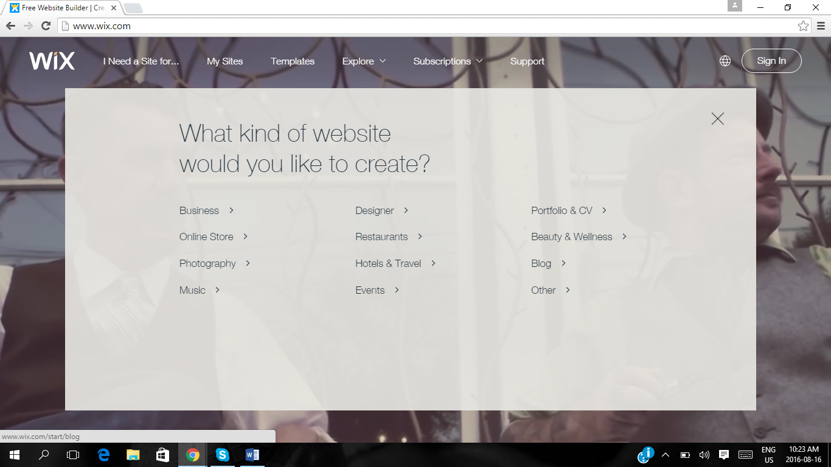



Wait on website prompt (or option top left corner) and choose the TYPE of website you want to design.

For Assignment 1, choose Blog.

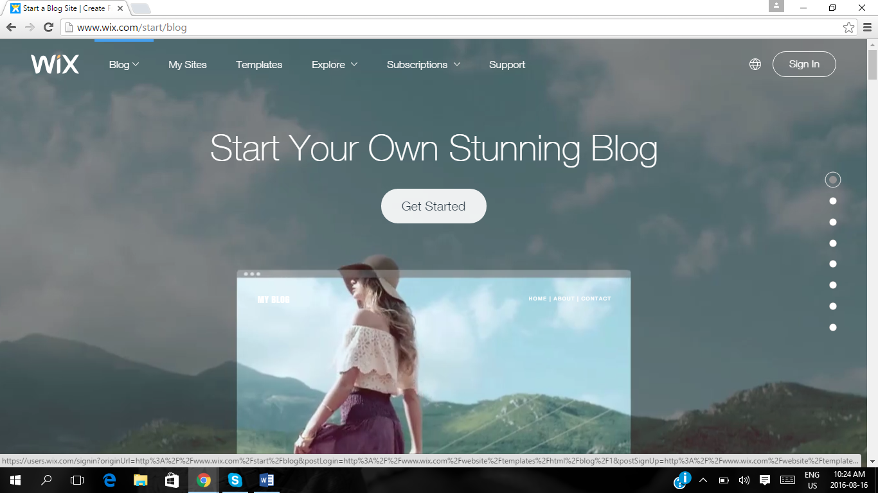



Follow website prompts, and click on GET STARTED

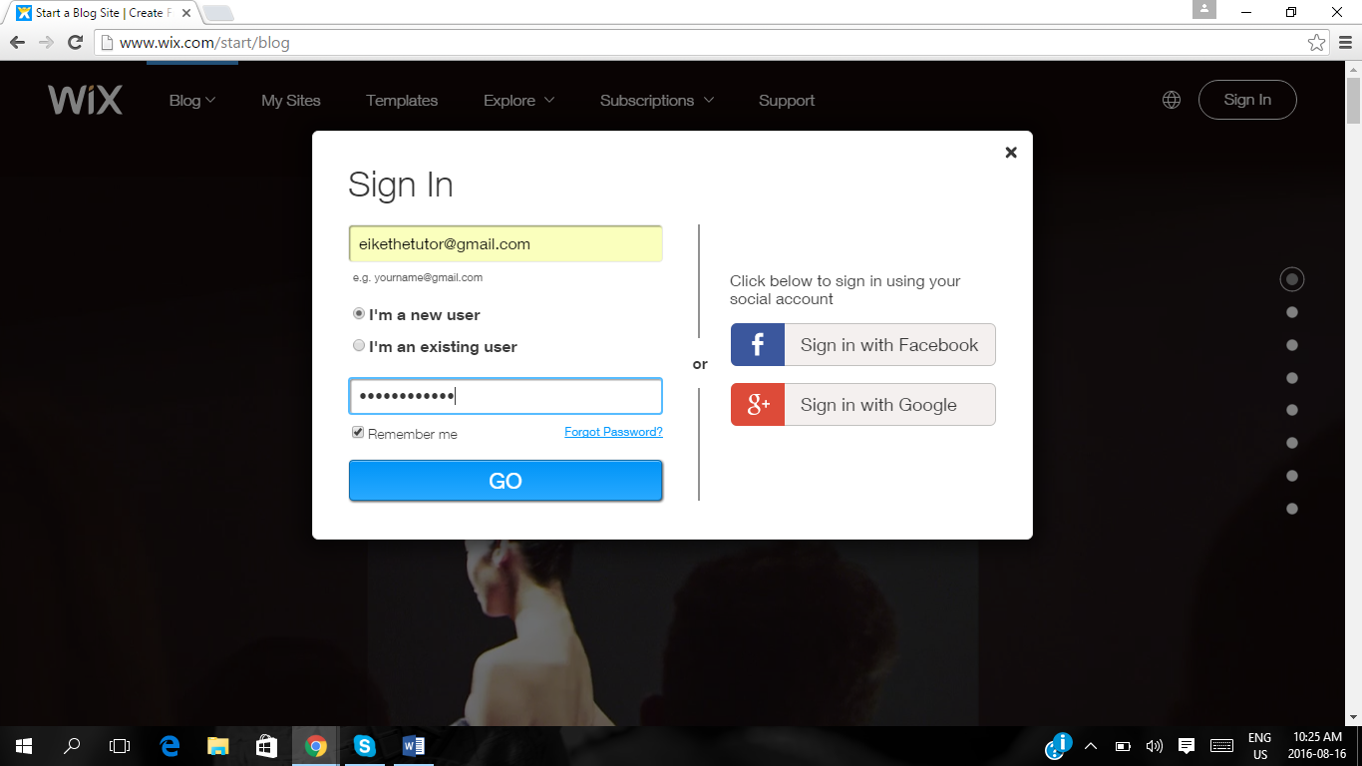



If you are a first timer to the website, you have to register. You can use your Facebook sign in OR your Gmail account sign in OR create a new username & password.

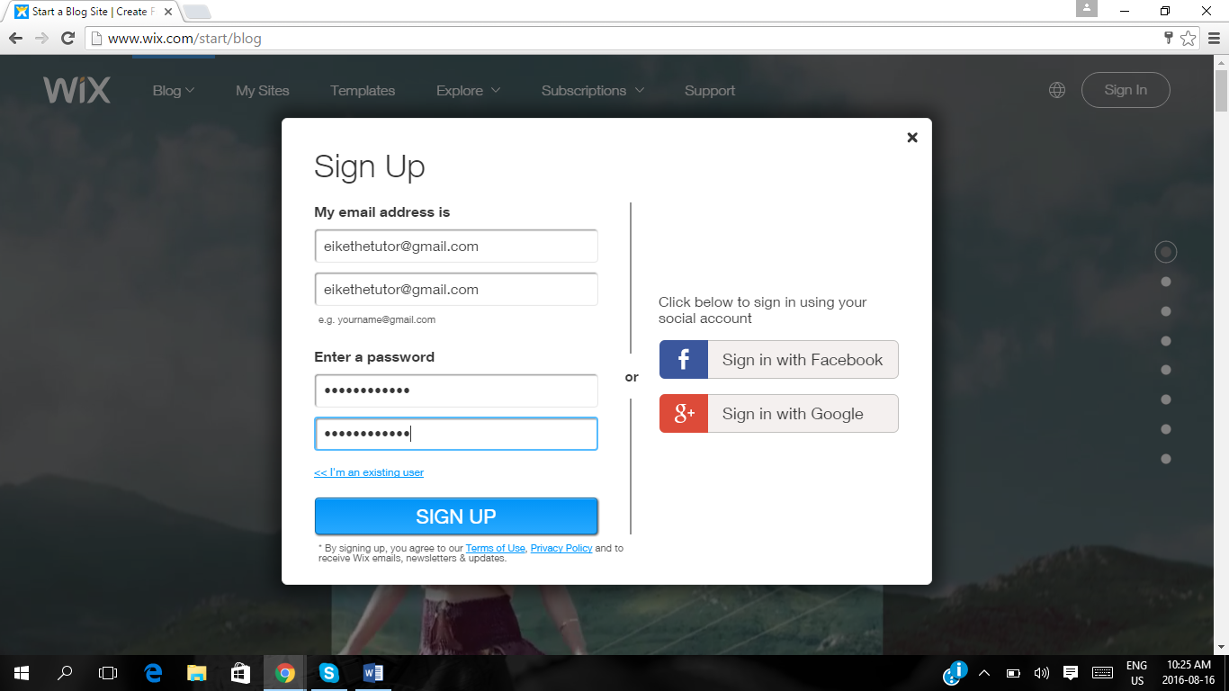



Website will prompt you to affirm your username and password detail. There after click on SIGN UP.

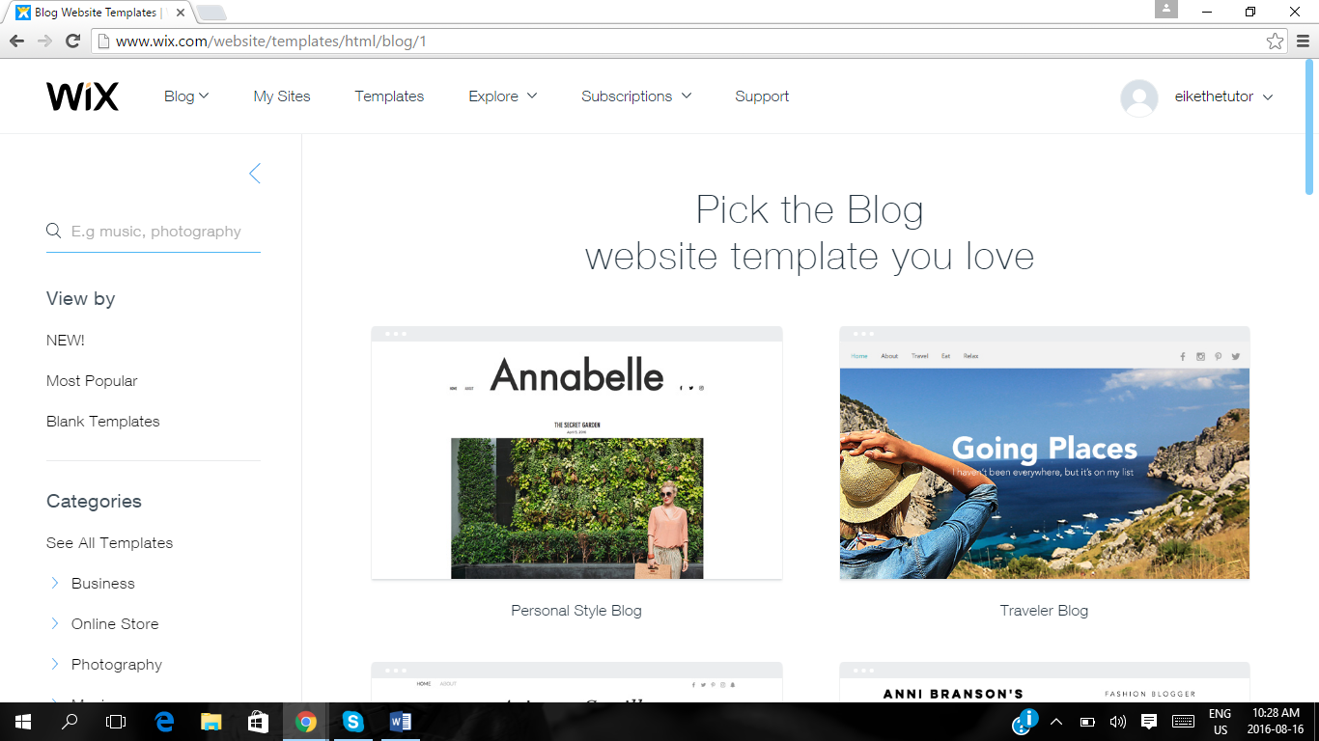



Browse the different BLOG TEMPLATES and choose you like.

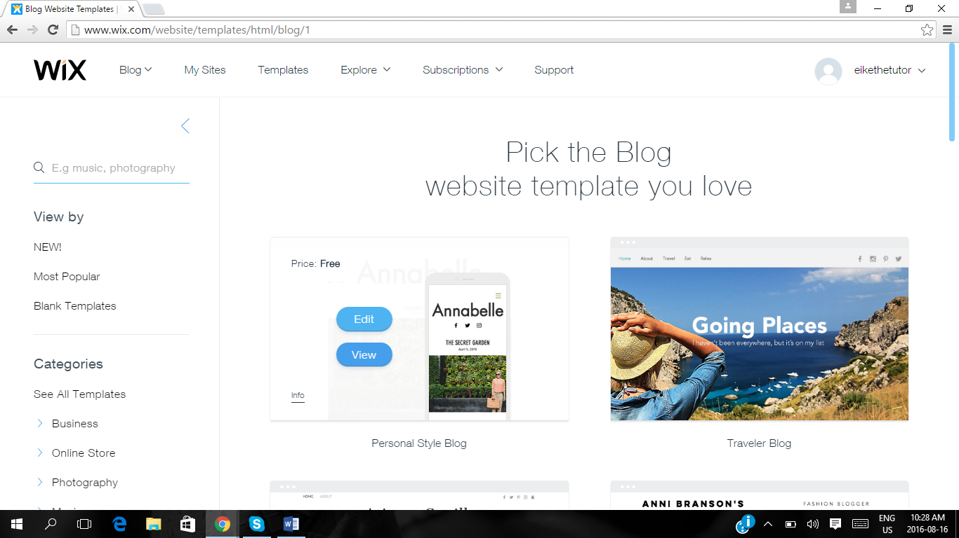



When you hover over your choice, click on the EDIT button.

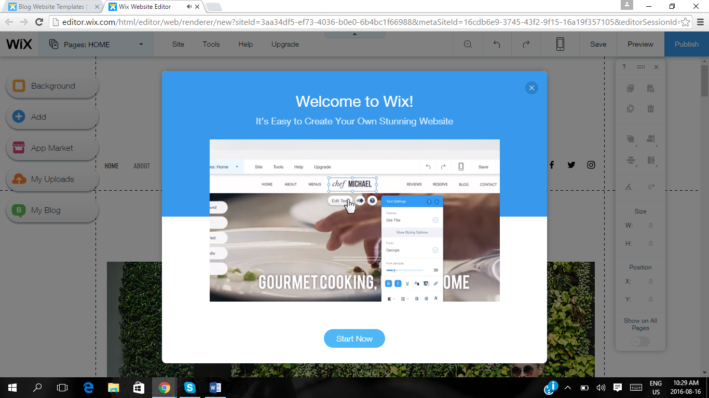



Follow website prompts and choose START NOW.

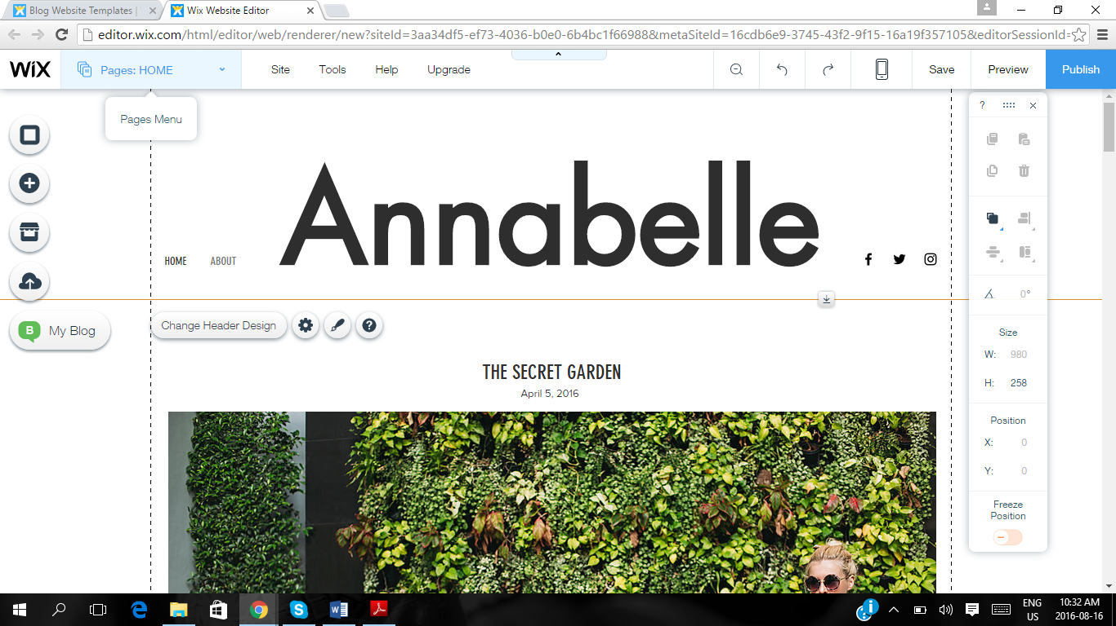



Locate the Pages tab

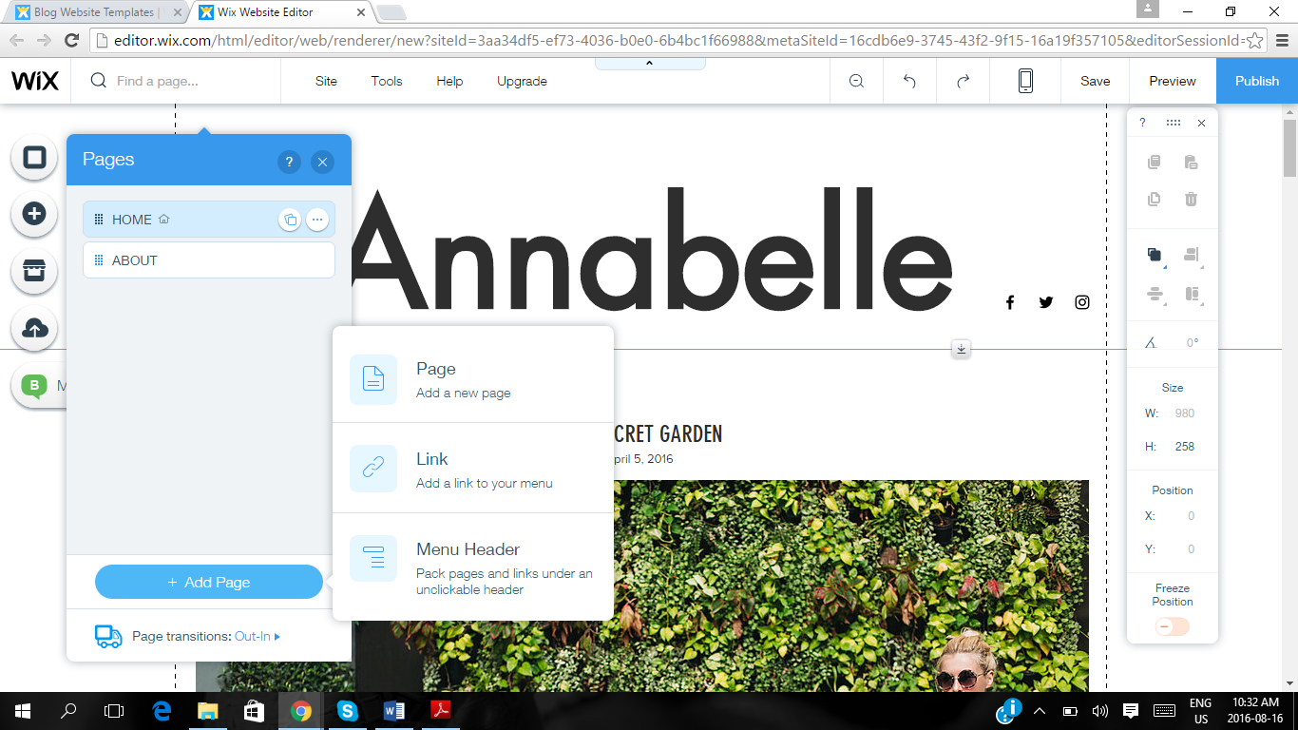



Top left hand corner, activate the PAGES drop down menu and ADD enough pages (For Assignment 1, six pages are recommended)

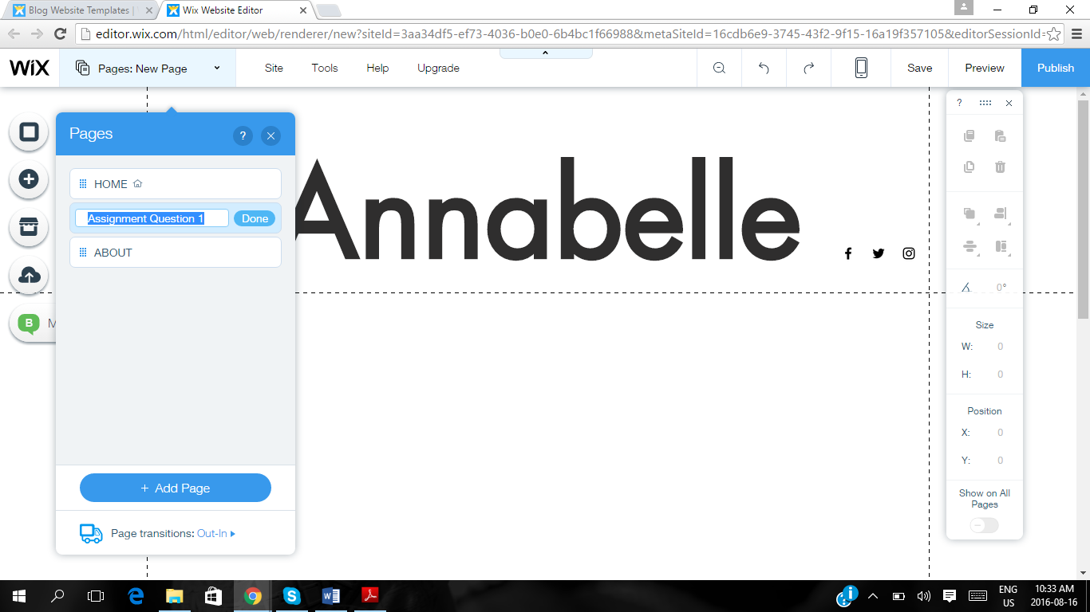



Each time when you ADD PAGE, you should label them separately. (For Assignment 1, label pages 1 to 5 as well as Reference List page).

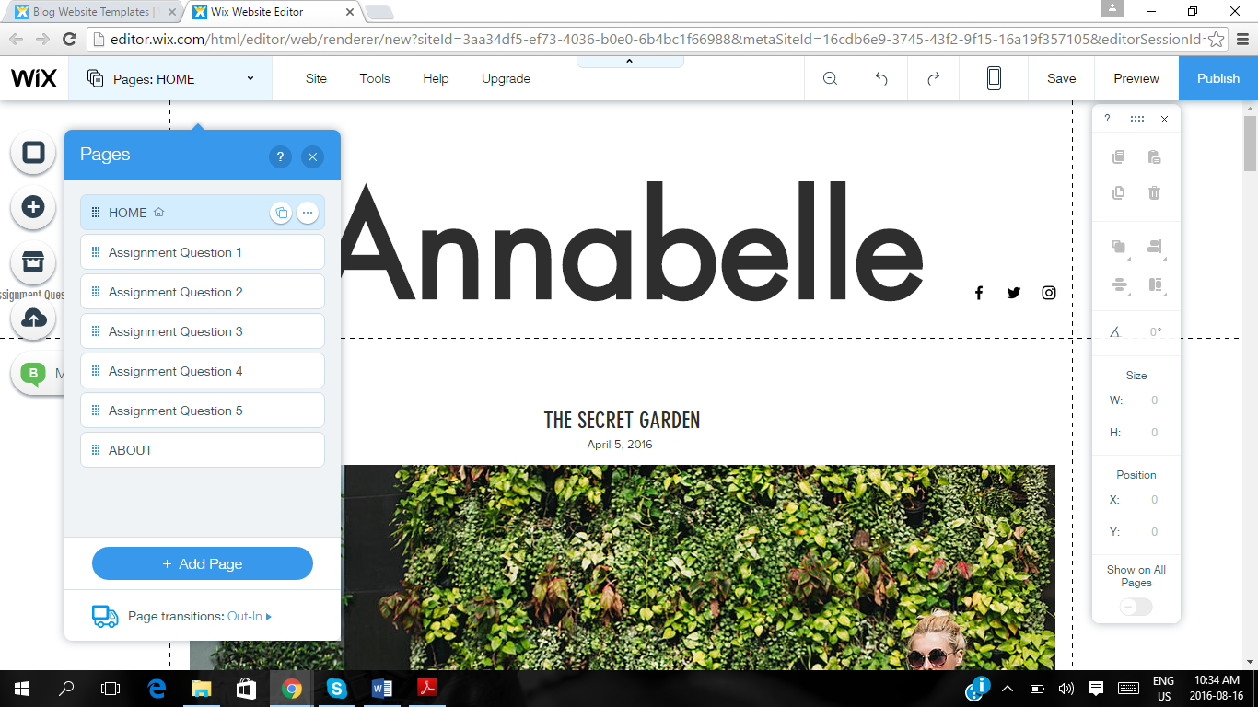



Example of PAGES created, for every question of the Assignment.

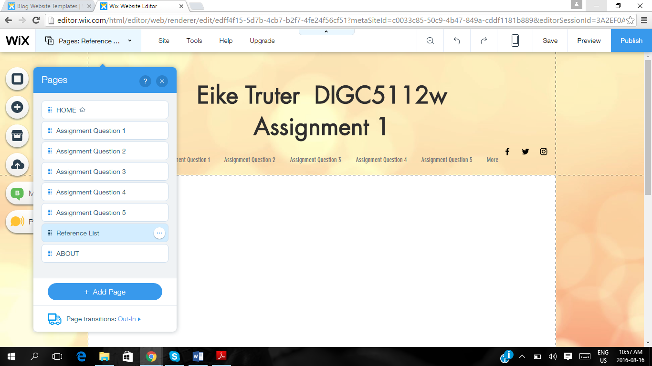



ADD a sixth PAGE, which you label REFERENCE LIST.

Now you have created 6 pages on your blog website, well done!

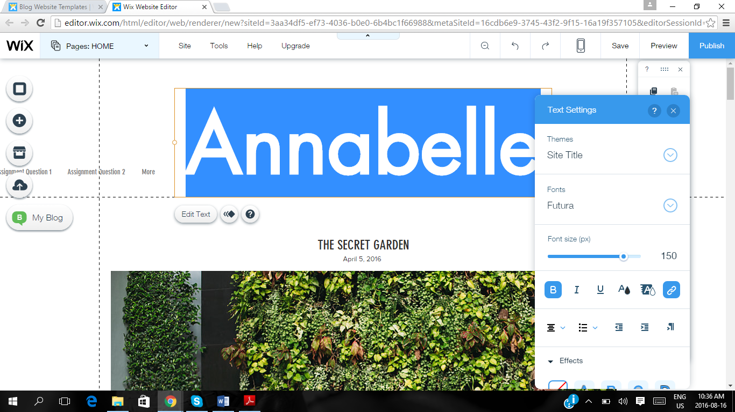



Double click on the preloaded topics/headings if you want to change them. The website will prompt you with a drop down menu to change the font size/type/colour. For headings, size 50 is recommended. For sub headings, size 20-30.

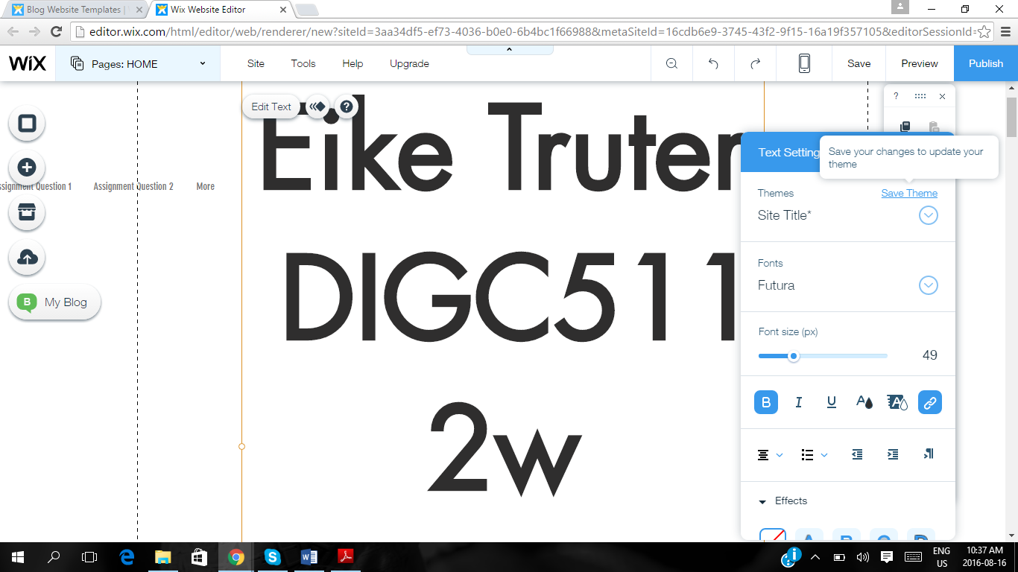

When you have adapted your font, choose the SAVE CHANGES option on the DROP DOWN MENU.

NOT the Save button in the top right hand corner, this is to conduct a major Save of your website design.

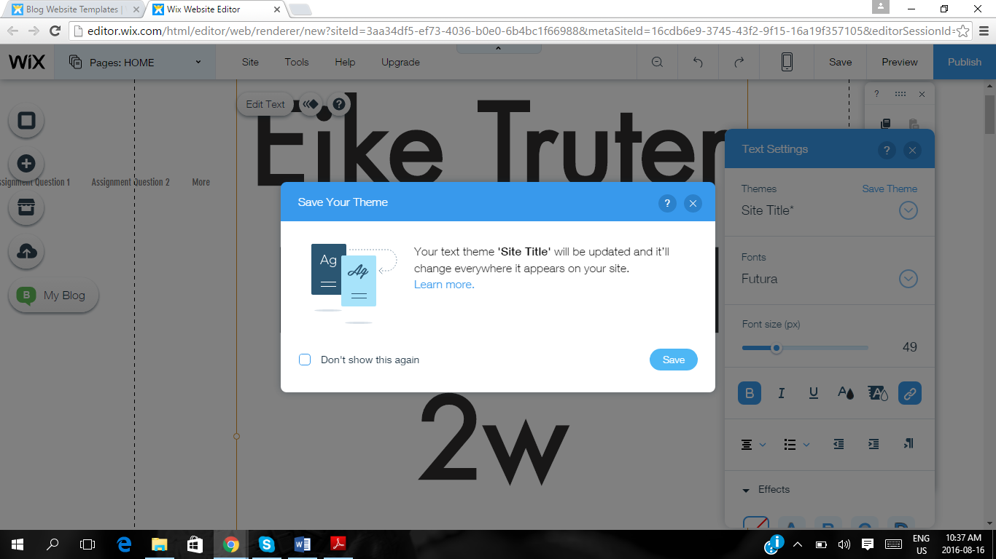



Website will prompt you to save your SITE TITLE. This title will appear on every page, as the heading to each blog page. Click on Save.

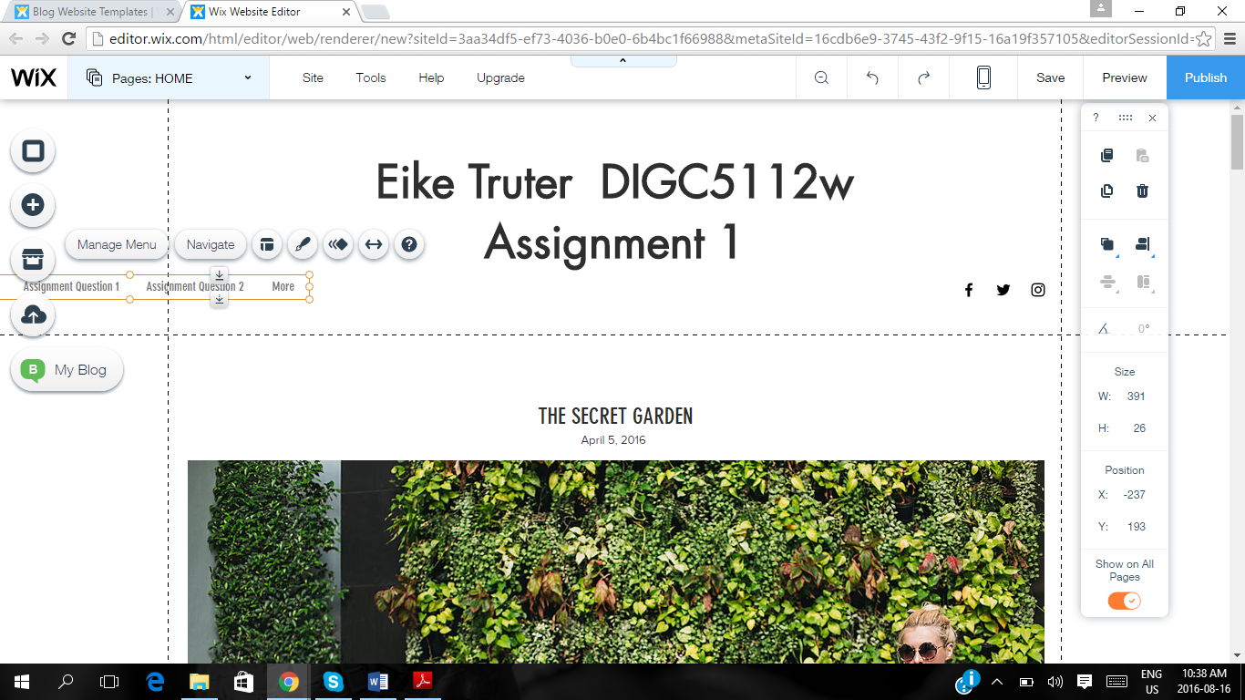



Locate your PAGES BAR and drag and drop it to a more suitable location. For example, underneath your Page Title.

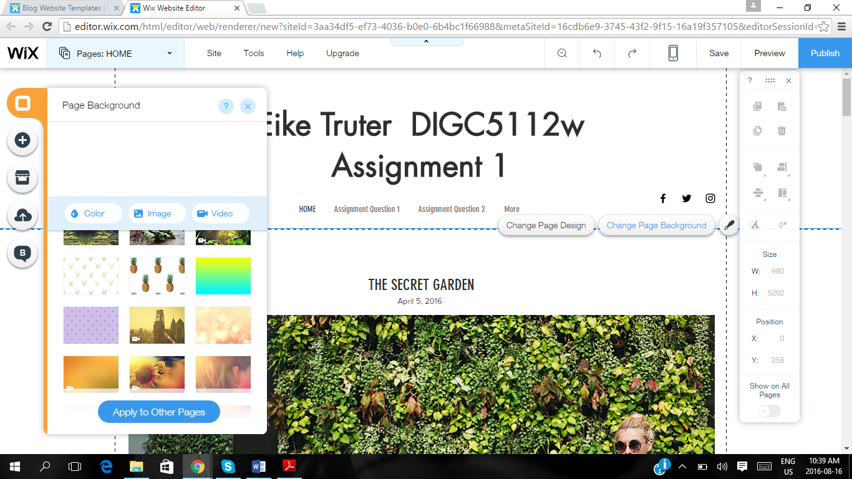



You have the option to change the background of the blog/website. The website will automatically populate all of your pages with the same background.

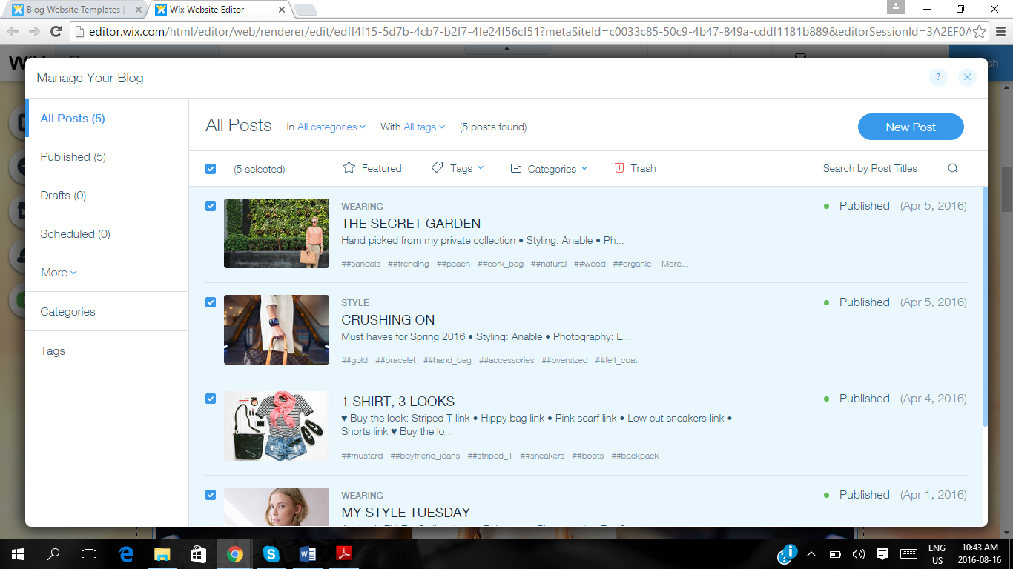



Choose the option MANAGE YOUR BLOG and DELETE the pre-created pages from the website. Now you have a blank canvas to work on.

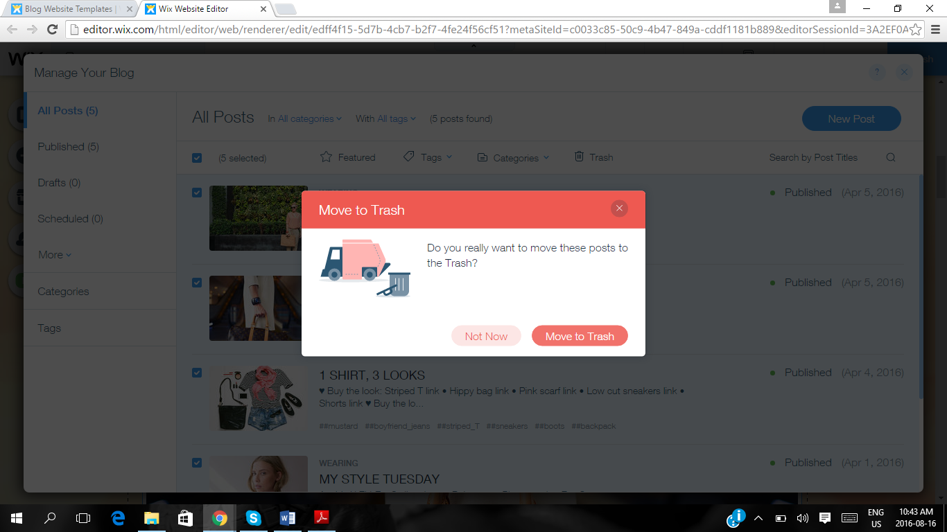



Confirm that you want to delete these pages.

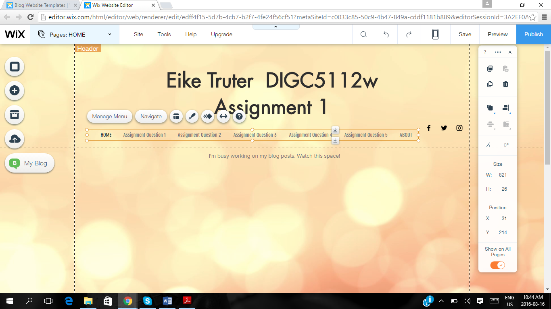

Now you have created the framework for your blog, including 6 pages, a home page, a title and navigation bar. Well done!

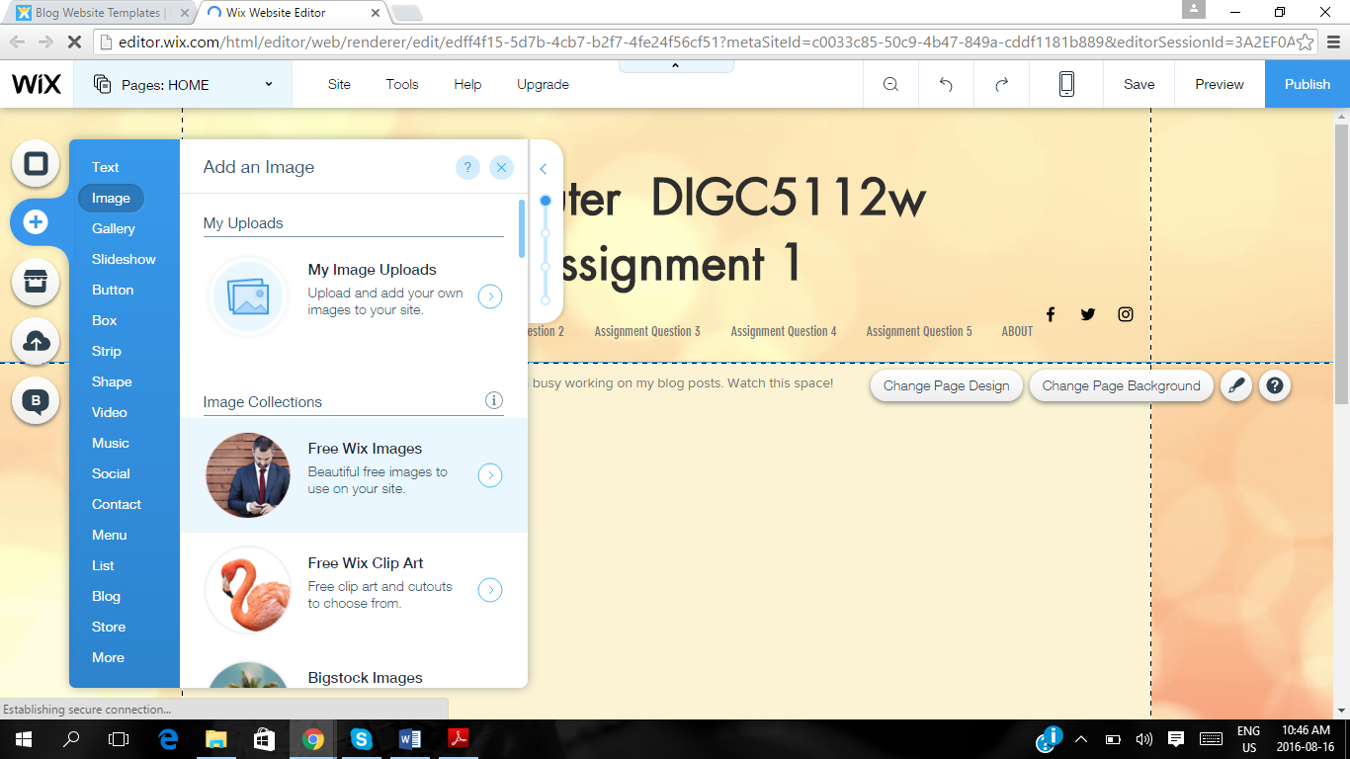

NOTE: FIRST write/answer your COMPLETE Assignment on a WORD DOCUMENT (Or PowerPoint slides as per question request). Then you can just proceed to UPLOAD every page’s content here.

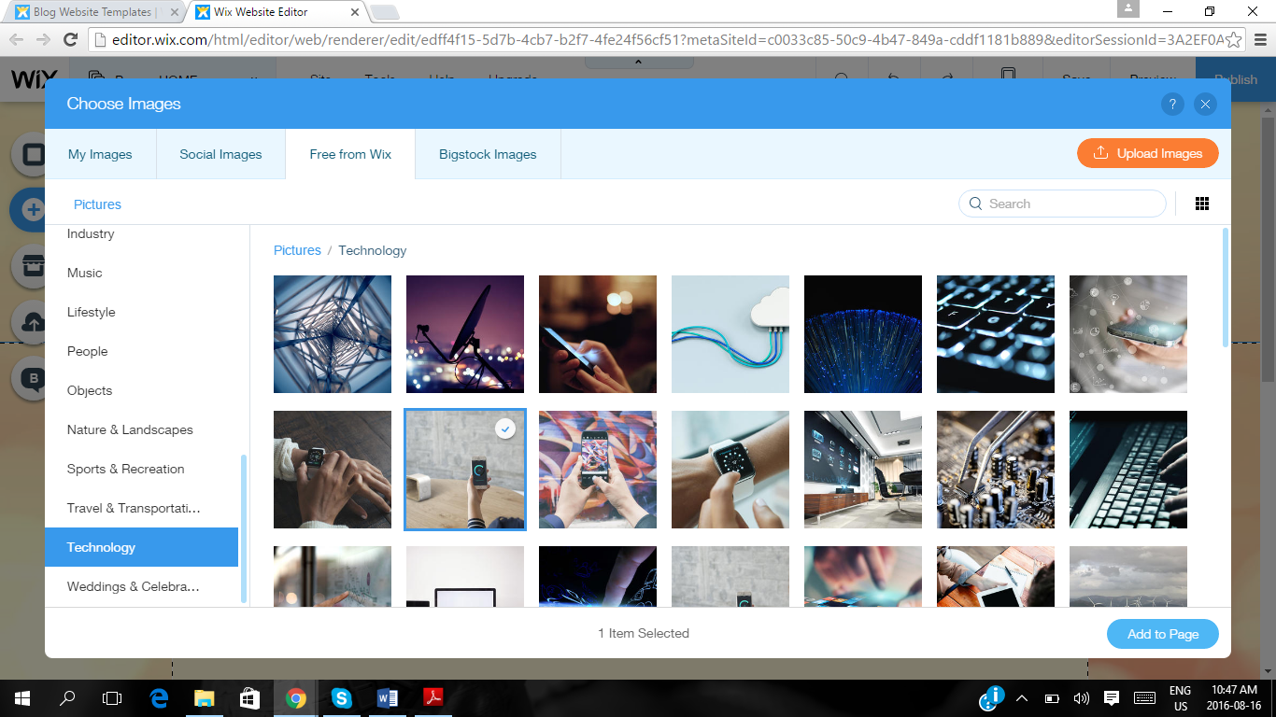

This is an example of the websites own image bank, if you want to add images to your individual pages. Graphics are always a good idea, as it keeps the reader interested.

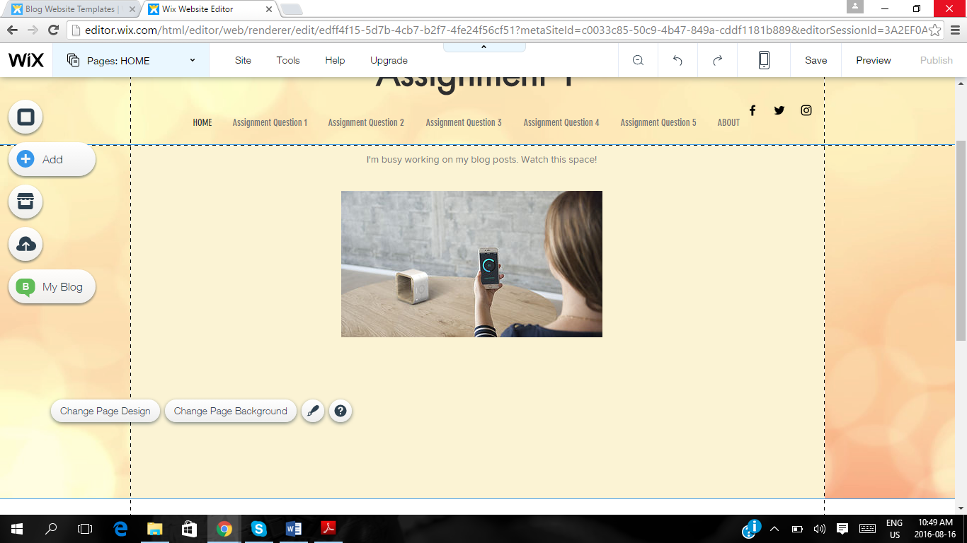

The website prompts you to move uploaded graphics around, on the page, so you are happy with the location.

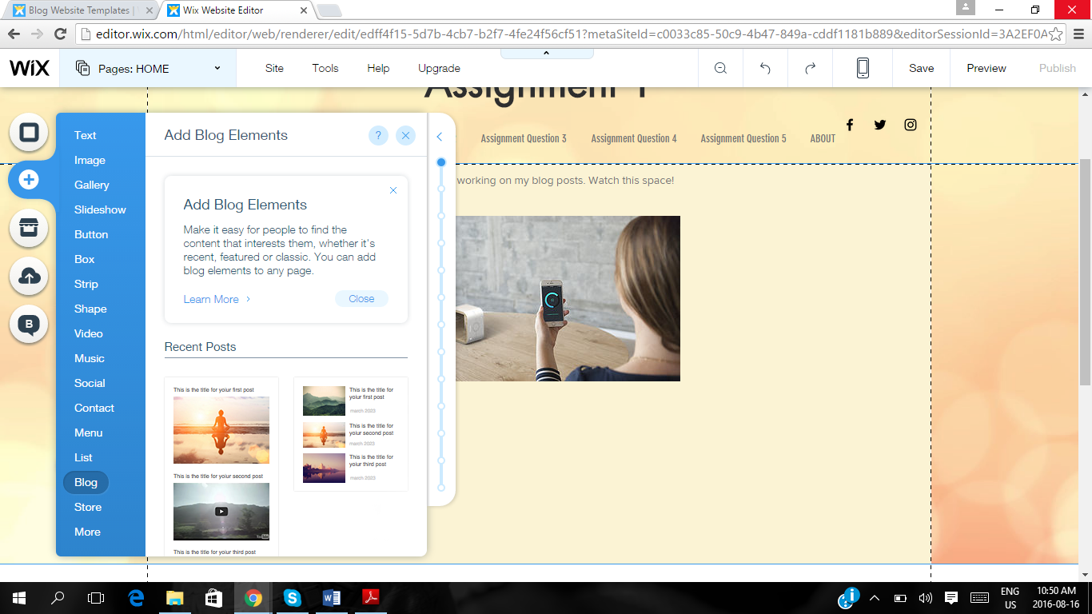



Now follows the big upload of your pre-written content. You have to add the ‘framework’ or window first to the page, and then copy and paste your content INTO that frame.

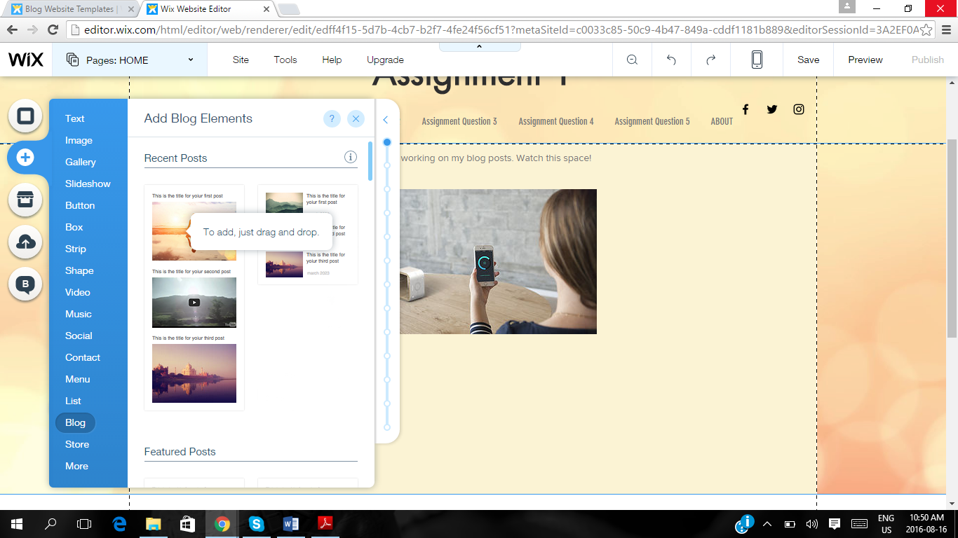



Drag and drop the ‘frame’ that will house your content onto your blog page.

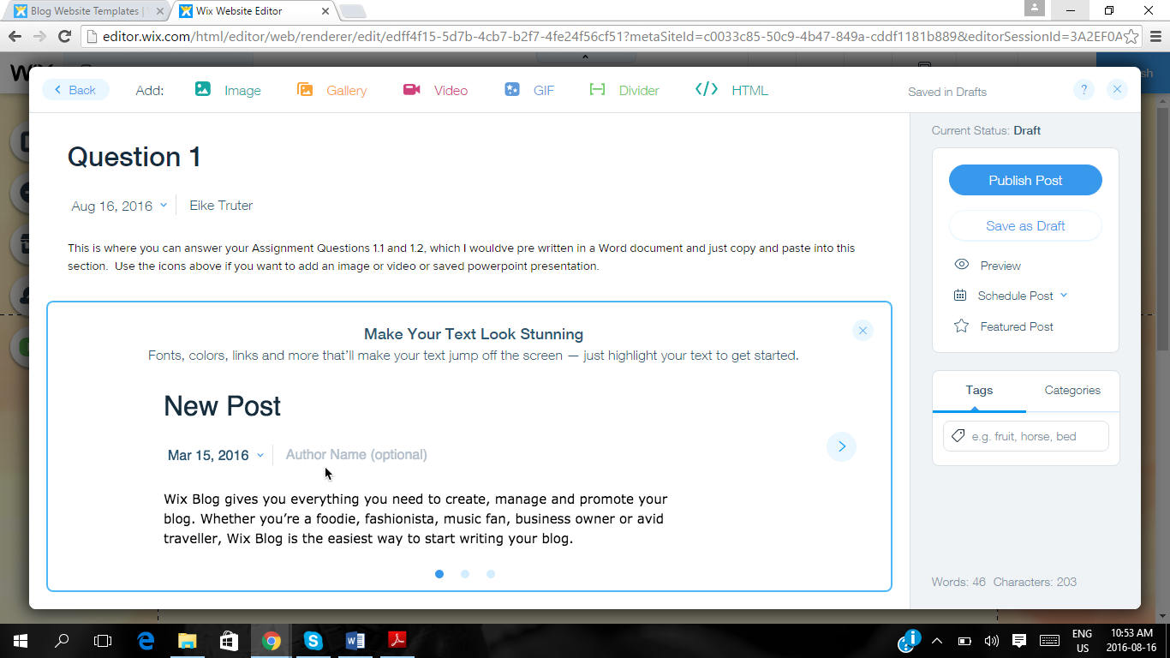



Each ‘frame’ will provide you with the opportunity to add a title, the date, your name and the actual written content.

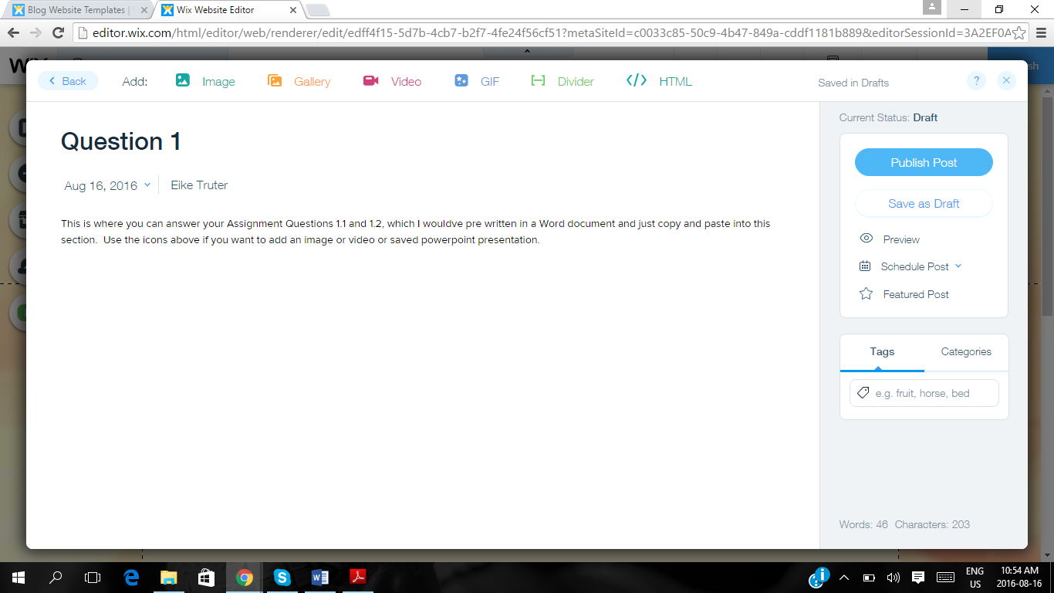

See example of written text adapted.

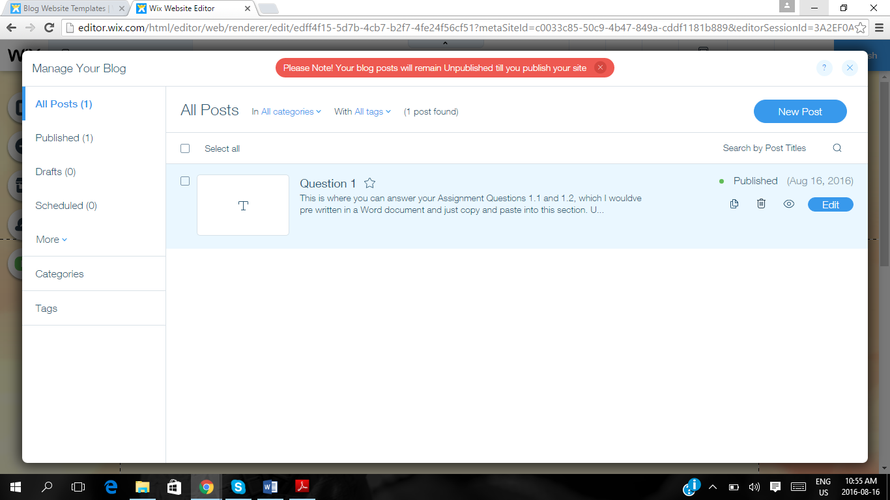



MANAGE YOUR BLOG is where you will see the overview of EVERY PAGE you have loaded or EDIT content of.

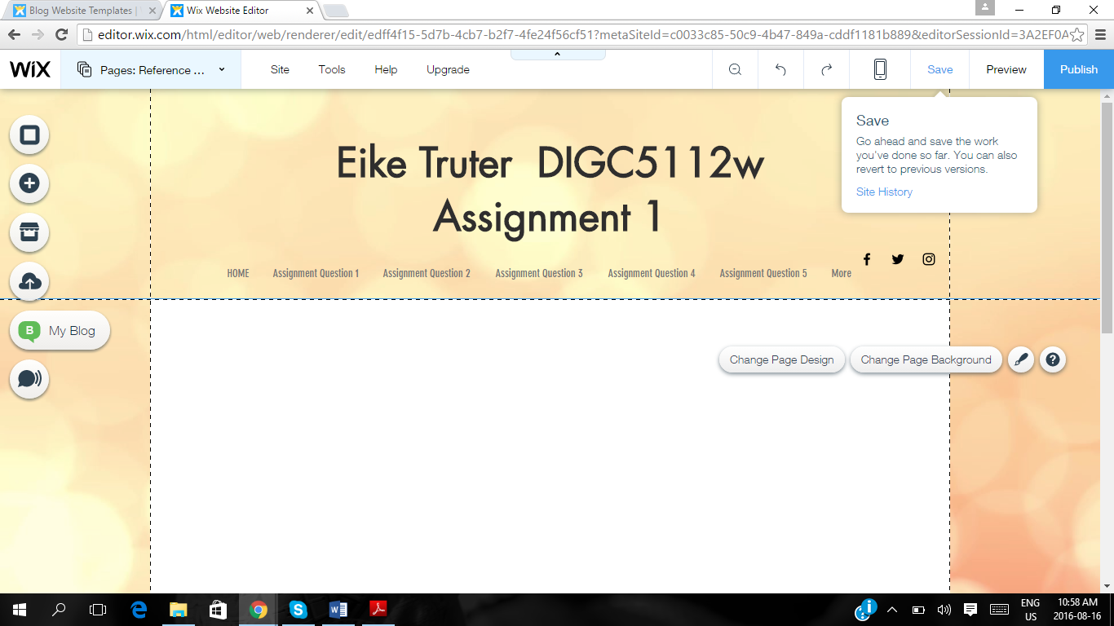

As you work on your website, you have the option to SAVE in the top right hand corner. Then you can return and work on the website again.

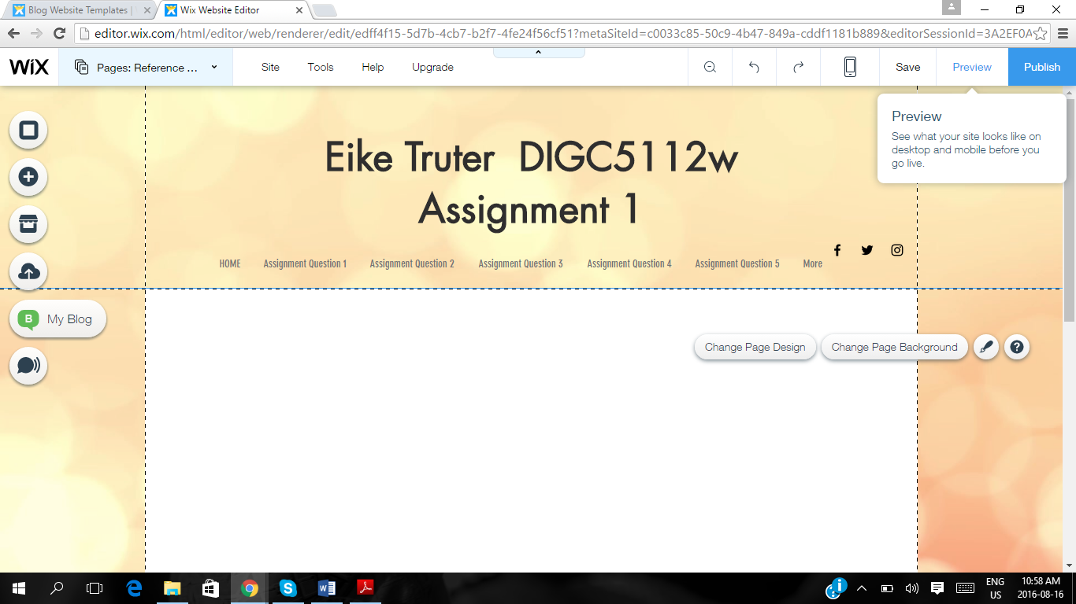

The PREVIEW function allows you to momentarily SEE/VIEW HOW your Blog/Website will LOOK when its published online.

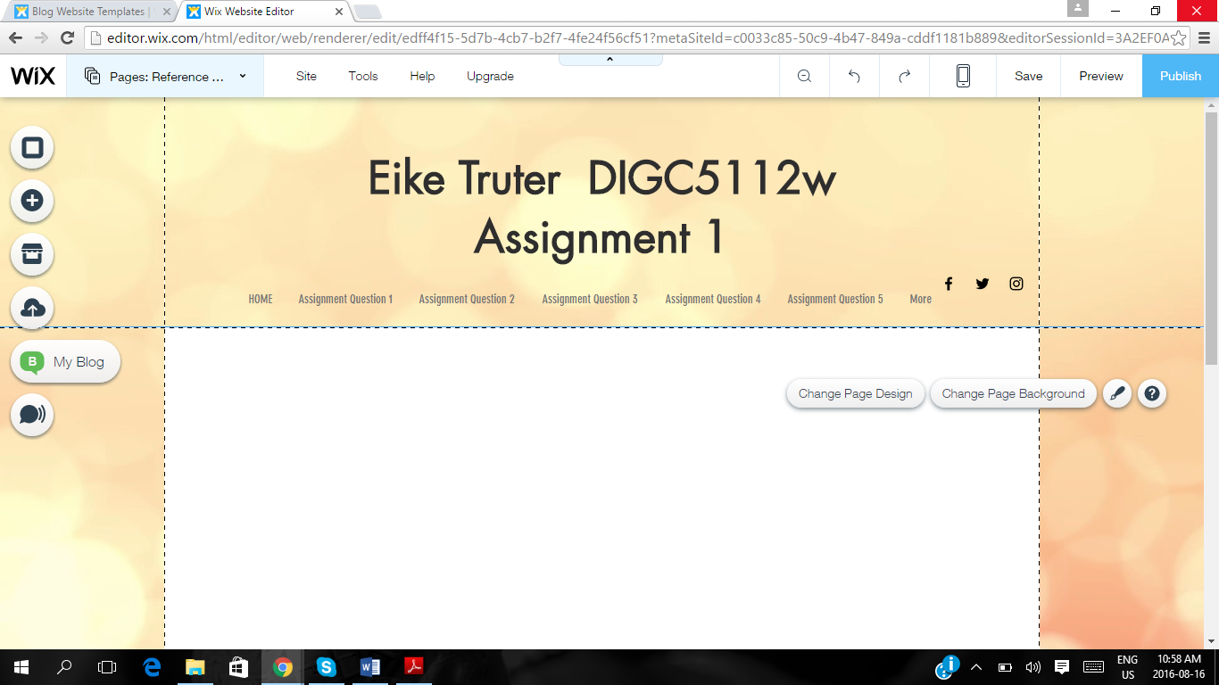

PUBLISH – You ONLY choose this option when you are DONE and READY to send your blog onto the internet.

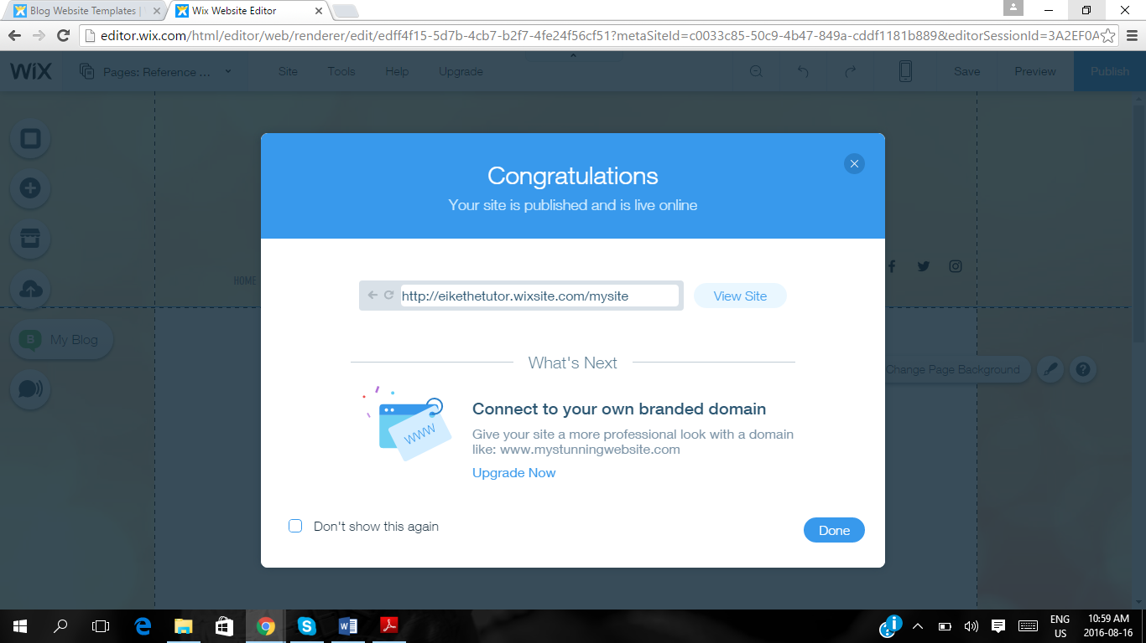

Copy and Paste the URL – as you will submit this URL to your tutor for marking.

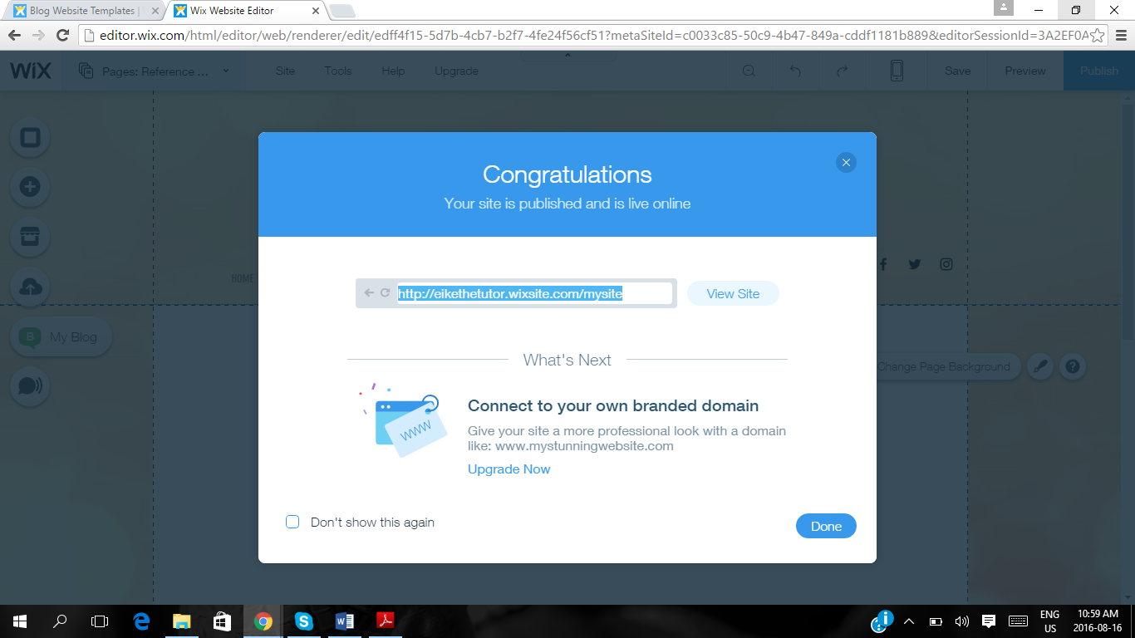



Choose the DONE option when you have copied the URL.

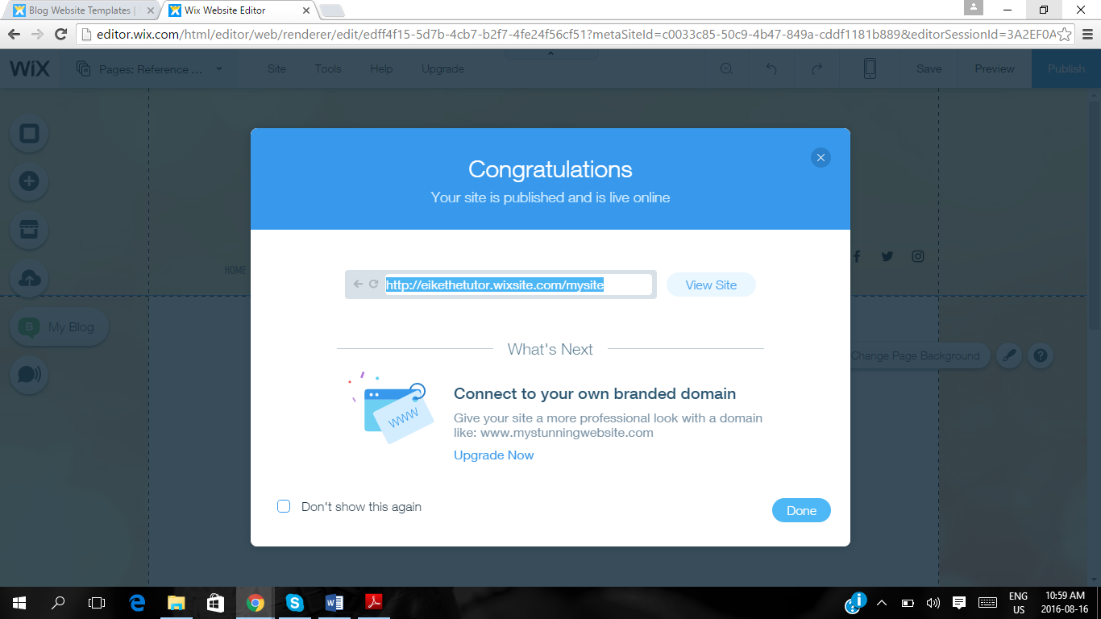

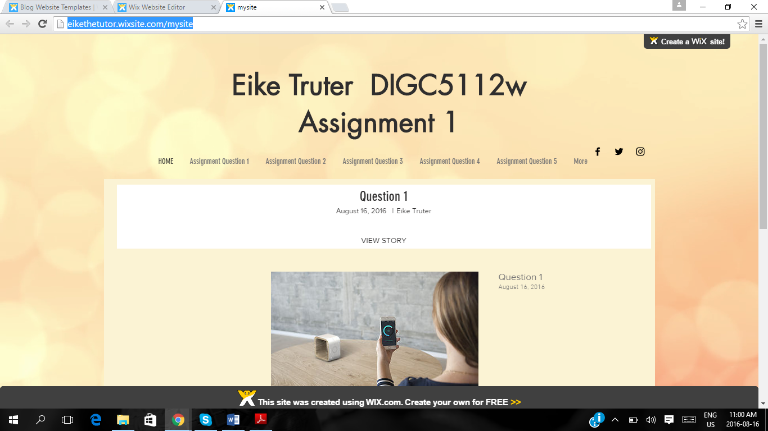

Now you can VIEW your own website online. The tutor will use this VIEW to mark your Assignment as well as your POE.

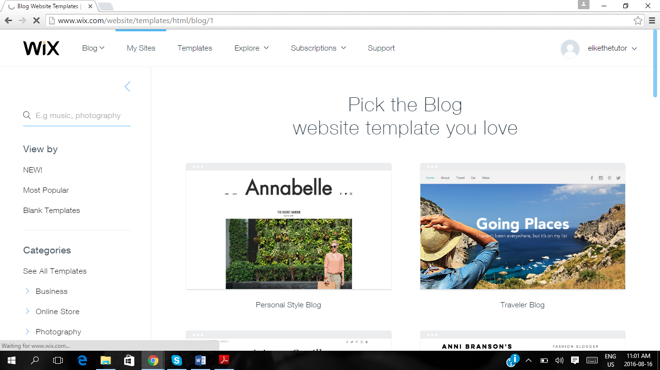



Next time, when you log into your Wix account, choose MY SITE, and it will direct you to the blogs you have created. This is important, as for your POE – you will use THE SAME website and just ADD NEW PAGES.

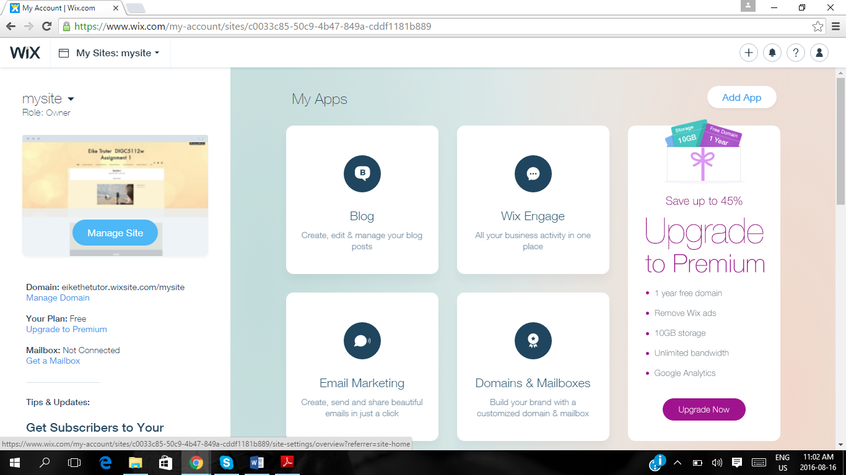



The website will prompt you to upgrade, but this is not necessary. The free version is sufficient.

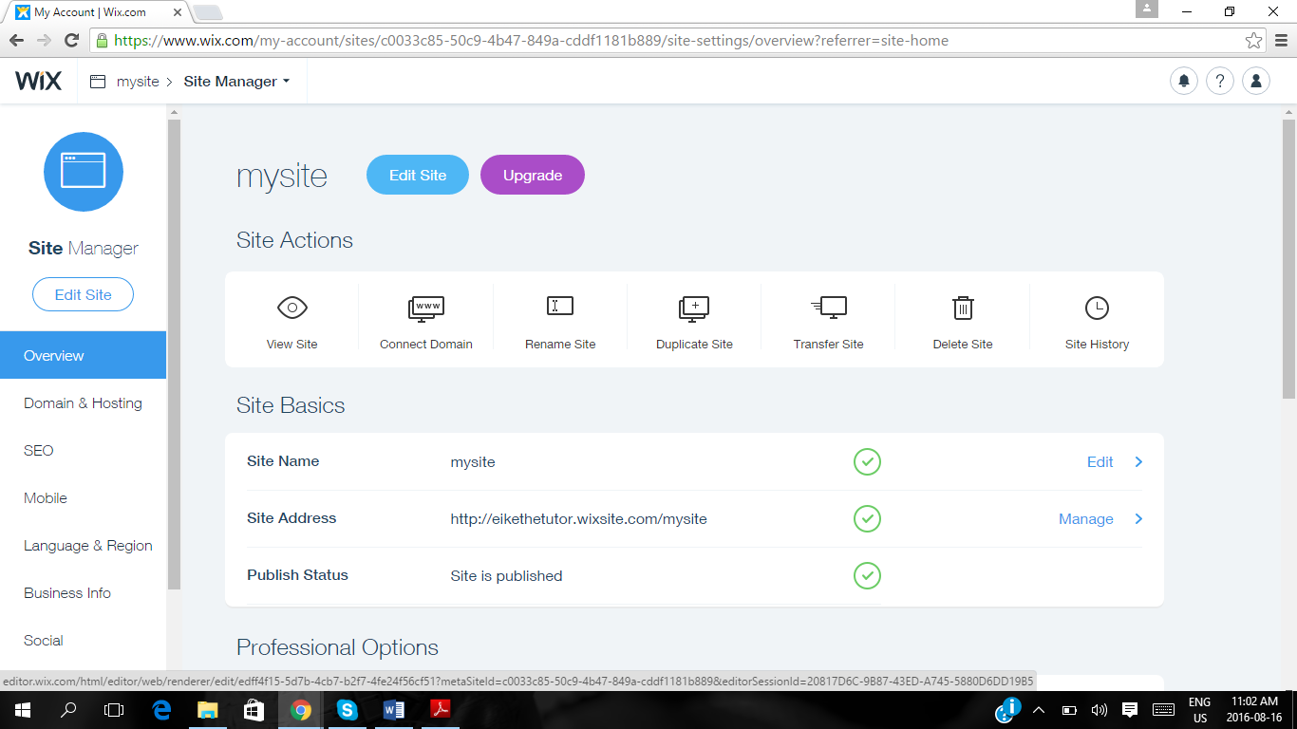

For the POE, when you have to make changes (ADD Pages) to your current website, just click on EDIT SITE.